**3.Existing System, Proposed System and UML Design**

As lot of institutes commonly prefer using **Google Drive,** these days to upload data or studying material. We can store all our files such as videos, photos, Google Docs, PDFs and etc. It can be managed by either an individual or joint venture, both parties can manage the drive efficiently.

But along with advantages comes disadvantages as well. Using Google Drive, Hackers or the attackers can hack or remove your important data or they install virus into your system and your files are gone. Another disadvantage can be the uploading and downloading speed when millions of users are uploading and downloading together, the speed will be slow down.

In the proposed system we our proposing an E-learning web-based system using cloud, which is specifically targeted towards engineering students and teachers, who can upload the studying material of respected course which can be of any form such as text files, videos, audios and students can access it from any location. Also we our providing test assessments for students who want to get thorough with their subjects. The main motive of our E-learning system is to provide efficient access and upload of materials as well keep the data secure from unauthorized users.

**System Architecture:**

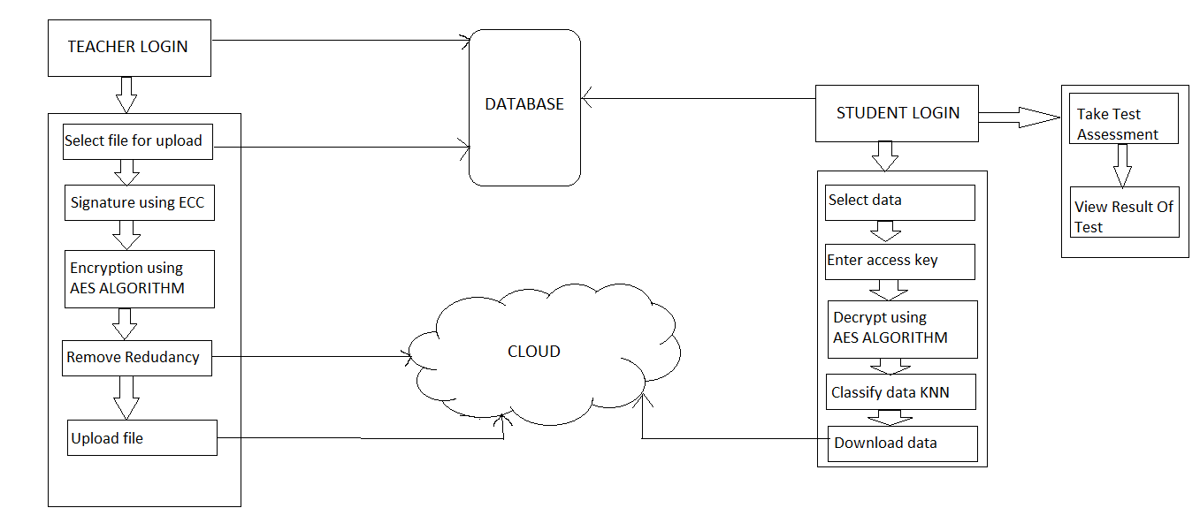

Figure1: System Architecture of Proposed design.

AS shown in figure1, the system consists of two entities who are going to interact with system first is the teacher and second is the student. Each teacher and student will have to first register to the system. Once registration is done the teacher as well as the student can login into the system by providing valid credentials. The teacher can upload the chosen material, every material which is to be uploaded on the cloud will be assigned a unique key so as to avoid redundant material on cloud, this unique key will be generated by using the Elliptic Curve Cryptography (ECC) Algorithm. The next step will be securing the data i.e. encrypting the data which is done by using Advanced Encryption Standard (AES) Algorithm, then the data is further uploaded on the cloud. Simultaneously, the student can login into the system once registered successfully. Student can either access the uploaded data or might the take test assessment. Student can select their respective branch and the can choose the data or material they want to access. If the student wants to download the material, firstly he/she has to enter the unique key which has been sent to their respective mails. Upon entering the valid key they can download the material. The data is decrypted using the same algorithm which is used for encryption. We are also implementing the classification algorithm K-Nearest Neighbor (KNN), for department wise classification of data as well as classifying the test results taken by the student.

**UML Design:**

Following are the UML diagrams that show a visual representation of system.

1. Class Diagram: Class diagram gives the static view of an application. A class diagram describes the type of objects and their relationships involved in the system.

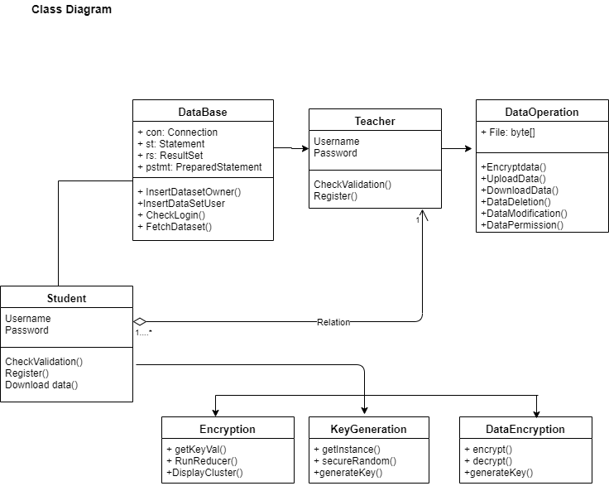

Figure2: Class Diagram

1. Use case Diagram: A use case diagram is dynamic or behavior diagram in UML. Use case diagram model the functionality of a system using actors and use cases.

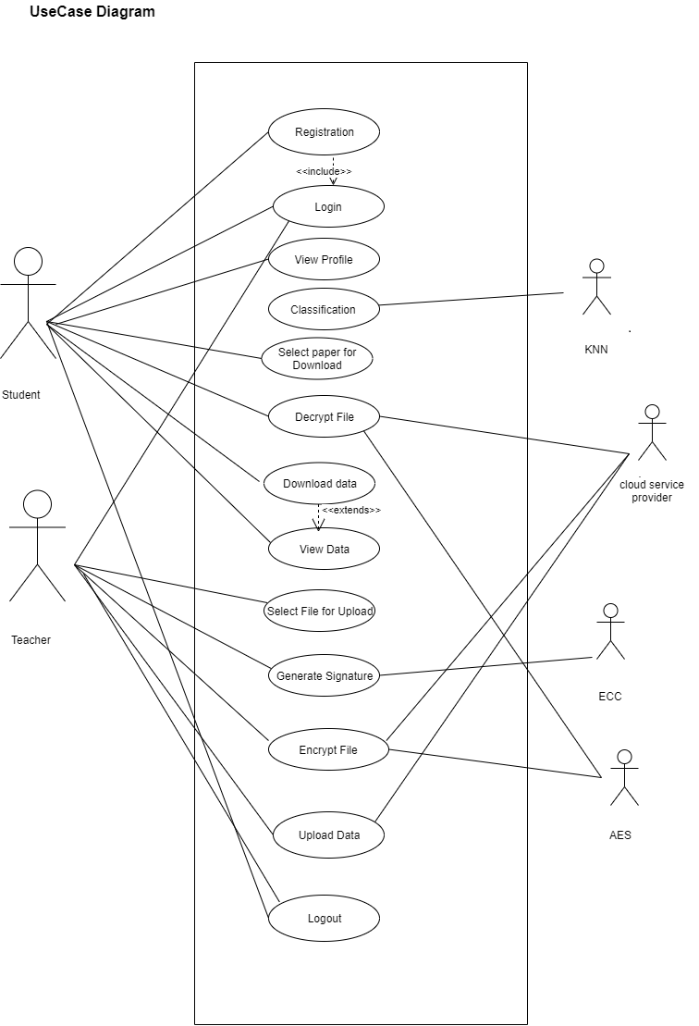

Figure3: Use case Diagram.